DEPARTMENT OF COMPUTER ENGINEERING
CLOUD COMPUTING & FRAMEWORKS
EXPERIMENT NO. 02
INSTALLATION AND CONFIGURATION OF KVM — A TYPE 1 HYPERVISOR
STUDENT DETAILS
Name: Sayyad Faizan
Class/Batch: TE CO - I 03
Roll No.: 24DCO11
Academic Year: 2024-2025
Subject: Cloud Computing & Frameworks (CCF)

1. Aim
To install and configure KVM (Kernel-based Virtual Machine), create and manage virtual machines, and explore paravirtualization settings using VirtIO devices.
2. Objectives
• Understand Virtualization, Hypervisors (Type 1 vs Type 2), and KVM architecture.
• Check hardware virtualization support on Linux using CLI commands.
• Install KVM, QEMU, libvirt, and virt-manager packages.
• Configure virtual machines, vCPUs, RAM, storage, and paravirtualized VirtIO drivers.
3. Theory & Concepts
3.1 Virtualization & Hypervisors
Virtualization enables a physical computer to run multiple isolated virtual machines (VMs). A Hypervisor or Virtual Machine Monitor (VMM) allocates physical vCPU, RAM, and storage hardware. Type 1 (bare-metal) hypervisors run directly on hardware or integrate closely into the host kernel (e.g., KVM, Xen, ESXi). Type 2 hypervisors run as applications on top of a host OS (e.g., VirtualBox).
3.2 KVM & VirtIO Paravirtualization
KVM turns the Linux kernel into a Type 1 hypervisor using Intel VT-x or AMD-V extensions. VirtIO provides paravirtualized drivers for disk and network adapters, bypassing emulated device bottlenecks for direct high-speed hypervisor I/O.
4. Step-by-Step Procedure & Screenshots
Step 1: Check Hardware Virtualization Support
Run command to check CPU virtualization flags:
Command: egrep -c '(vmx|svm)' /proc/cpuinfo
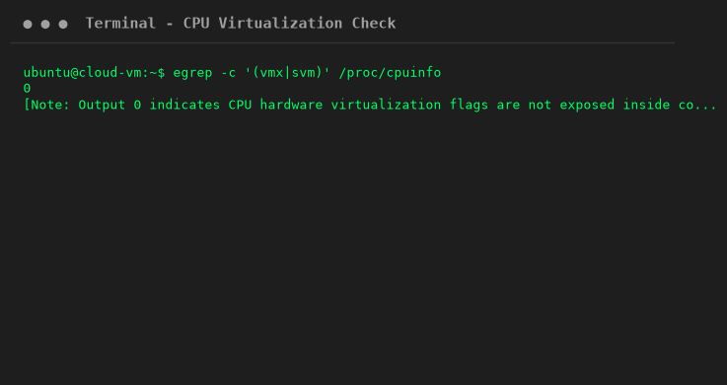
Note: Output returns 0 inside container environments where nested hardware virtualization flags are not exposed by the underlying host kernel.
Step 2: Update Packages & Install KVM Software
Install KVM and virtualization management utilities:
Command: sudo apt update && sudo apt install -y qemu-kvm libvirt-daemon-system libvirt-clients virt-manager ovmf
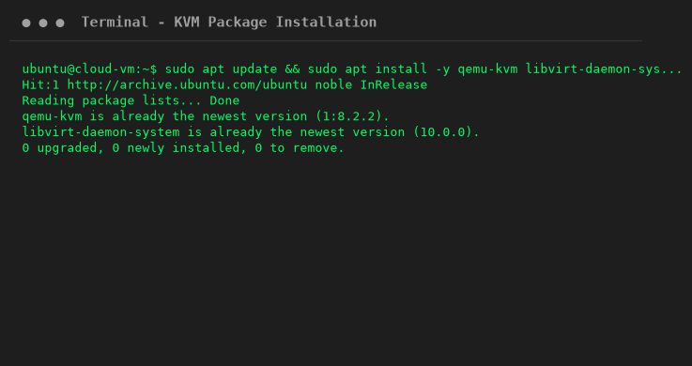
Step 3: Enable Libvirt Service & Verify /dev/kvm
Start the virtualization service and verify KVM device availability:
Command: sudo systemctl enable --now libvirtd && ls -l /dev/kvm && virsh list --all
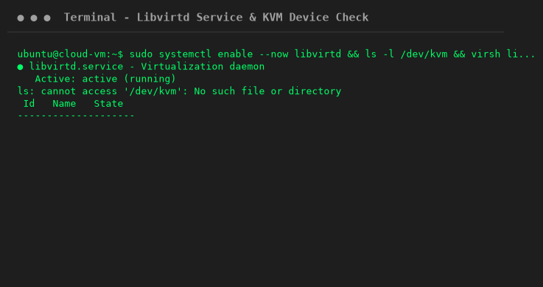
Step 4: Launch Virt-Manager & Select ISO Media
Open Virtual Machine Manager GUI and select guest ISO image and resource allocations:
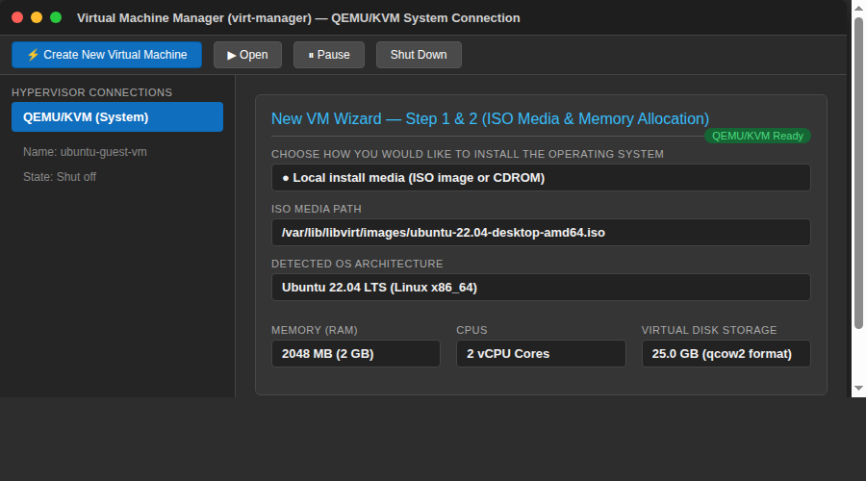
Step 5: Configure VirtIO Paravirtualized Devices
Configure VirtIO Disk Bus and Network Model in Virt-Manager hardware details:
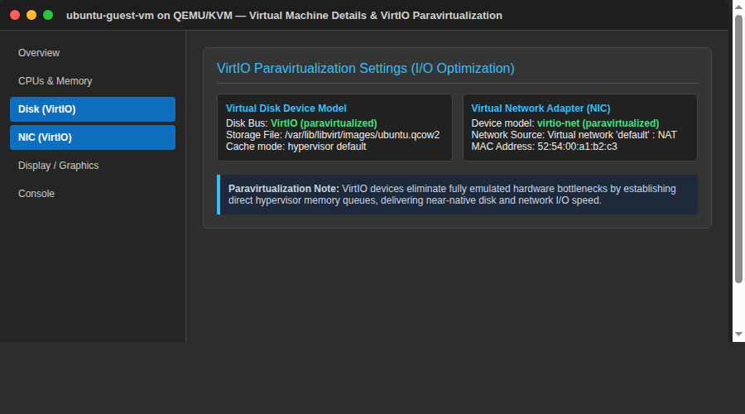
5. Viva Questions & Conclusion
Q1: What is KVM?
Ans: KVM is a Linux kernel module that turns Linux into a Type 1 bare-metal hypervisor.
Q2: What is VirtIO?
Ans: VirtIO is a standardized paravirtualized device driver framework that provides efficient guest I/O.
Q3: What command checks virtualization flags on Linux?
Ans: `egrep -c '(vmx|svm)' /proc/cpuinfo`
Q4: What is `virsh`?
Ans: `virsh` is the main management CLI utility for controlling libvirt domains/VMs.
6. Conclusion
In this experiment, KVM hypervisor installation, virtualization checks, libvirt daemon execution, and VirtIO paravirtualization configurations were studied and verified.

